INDEX
TOPIC PAGE NO

ABSTRACT ------------------------------------------------------------------------ 01 -02

TABLE OF CONTENT ------------------------------------------------------------- 03 -04

INTRODUCTION ------------------------------------------------------------------- 05 – 06

TECHNOLOGY USED ------------------------------------------------------------ 07 – 09

ANALYSIS -------------------------------------------------------------------------- 10 – 12

DESIGN ------------------------------------------------------------------------------ 13- 14

CODING ----------------------------------------------------------------------------- 15 – 24

OUTPUT------------------------------------------------------------------------------ 25

CONCLUSION ----------------------------------------------------------------------- 26-30

Abstract:
The Sleep Health and Lifestyle Dataset is a comprehensive collection of information and measurements related to sleep patterns and lifestyle factors of individuals. This dataset aims to provide valuable insights into the relationship between sleep health and various lifestyle variables, enabling researchers and practitioners to understand the impact of lifestyle choices on sleep quality and duration.

The dataset encompasses a wide range of variables, including demographic information, sleep characteristics, lifestyle habits, and health-related indicators. It consists of data collected from a diverse population sample, spanning different age groups, genders, and geographical locations. The dataset incorporates both self-reported information and objective measurements obtained through wearable devices and sleep monitoring technologies, ensuring a holistic representation of sleep health and lifestyle factors.

Key features of the Sleep Health and Lifestyle Dataset include sleep duration, sleep efficiency, sleep onset latency, and awakenings during sleep. Additionally, it includes lifestyle variables such as physical activity levels, caffeine and alcohol consumption, screen time exposure, stress levels, and chronotype (individual preference for timing of sleep and wakefulness). Health-related indicators, such as body mass index (BMI), sleep-related disorders, and overall well-being assessments, are also included to facilitate comprehensive analyses.

To ensure data integrity and privacy, strict ethical guidelines and anonymization techniques were employed during the data collection process. The dataset adheres to relevant data protection regulations and safeguards participant privacy and confidentiality.

Researchers and practitioners can leverage the Sleep Health and Lifestyle Dataset to explore various research questions and generate evidence-based insights. Potential applications include investigating the impact of lifestyle choices on sleep quality, identifying associations between sleep health and specific health outcomes, and developing personalized interventions to improve sleep patterns and overall well-being.

Overall, the Sleep Health and Lifestyle Dataset provides a valuable resource for the scientific community to advance the understanding of sleep health and lifestyle factors. By utilizing this dataset, researchers and practitioners can contribute to the development of evidence-based strategies aimed at promoting healthy sleep habits and improving overall sleep health in individuals and populations.

Introduction

1. Overview:
The Sleep Health and Lifestyle Dataset is a comprehensive collection of data that captures various aspects of sleep patterns, lifestyle factors, and their relationship to overall health and well-being. This dataset is designed to facilitate research and analysis in the field of sleep science, enabling researchers and healthcare professionals to gain insights into the impact of sleep and lifestyle on various health outcomes.

2. Data Sources:
The dataset incorporates data from multiple sources, including surveys, wearable devices, mobile applications, and medical records. It includes self-reported information provided by individuals as well as objective measurements collected through sensors and devices.

3. Key Variables:
The dataset encompasses a wide range of variables related to sleep health and lifestyle. Some of the key variables include:
- Sleep Duration: The total amount of time an individual spends asleep each night.
- Sleep Efficiency: The percentage of time spent asleep compared to the total time spent in bed.
- Sleep Quality: Subjective ratings of the perceived quality of sleep.
- Sleep Disturbances: Incidents of interruptions or disruptions during sleep.
- Chronotype: Individual preferences for sleep timing (e.g., morning person or night owl).
- Lifestyle Factors: Information on exercise habits, diet, caffeine and alcohol consumption, screen time, and other relevant lifestyle choices.
- Health Outcomes: Measures of physical and mental health, such as body mass index (BMI), cardiovascular health, mental well-being, and chronic conditions.

4. Sample Size and Diversity:
The dataset comprises a diverse sample of individuals across different age groups, genders, geographic locations, and socioeconomic backgrounds. This diversity ensures that the dataset captures a broad range of sleep patterns and lifestyle behaviors, providing a more comprehensive understanding of their associations with health outcomes.

5. Data Collection Methods:
Data collection methods include both self-reporting and objective measurements. Self-reporting involves participants answering surveys and questionnaires related to sleep habits and lifestyle factors. Objective measurements are obtained through wearable devices and sensors that track sleep duration, movement, heart rate, and other physiological indicators.

6. Data Privacy and Ethics:
To ensure the privacy and confidentiality of participants, appropriate data anonymization and encryption techniques have been applied to remove personally identifiable information. Ethical considerations and guidelines have been followed throughout the data collection process to protect the rights and well-being of participants.

7. Potential Applications:
The Sleep Health and Lifestyle Dataset holds immense potential for various applications, including:
- Sleep Research: Investigating the relationship between sleep patterns, lifestyle factors, and specific health outcomes.
- Health Interventions: Designing personalized interventions to improve sleep quality and overall health.
- Public Health Initiatives: Informing public health policies and campaigns aimed at promoting healthy sleep practices.
- Technology Development: Enhancing the accuracy and effectiveness of sleep-tracking devices and applications.

In conclusion, the Sleep Health and Lifestyle Dataset provides a valuable resource for researchers and healthcare professionals to explore the complex interactions between sleep, lifestyle, and health. By leveraging this dataset, researchers can gain new insights and develop evidence-based strategies to promote optimal sleep health and improve overall well-being.

Literature Survey

Introduction:
Sleep health and lifestyle play a crucial role in maintaining overall well-being and quality of life. Researchers and healthcare professionals often rely on datasets to study various aspects of sleep, such as sleep patterns, sleep disorders, and their relationship with lifestyle factors. Conducting a literature survey helps in understanding the existing datasets available for studying sleep health and lifestyle and provides insights into the research conducted in this domain. Here is an overview of some notable datasets used in the field of sleep health and lifestyle research:

1. National Sleep Research Resource (NSRR):
The NSRR is a comprehensive open-access repository of datasets collected from multiple sleep research studies. It provides access to a diverse range of data, including polysomnography recordings, sleep questionnaires, and demographic information. Researchers can access this dataset to investigate sleep disorders, sleep patterns, and their associations with various health outcomes.

2. Sleep Heart Health Study (SHHS):
The SHHS dataset is a prominent resource for studying the relationship between sleep disorders, cardiovascular health, and other comorbid conditions. It includes polysomnography data, sleep questionnaires, medical history, and follow-up information from a large cohort of individuals. The SHHS dataset has been widely used to explore the impact of sleep-disordered breathing, such as sleep apnea, on cardiovascular outcomes.

3. Pittsburgh Sleep Quality Index (PSQI) Dataset:
The PSQI dataset consists of self-reported sleep quality data obtained using the Pittsburgh Sleep Quality Index questionnaire. It encompasses information on various sleep parameters, such as sleep duration, sleep disturbances, sleep efficiency, and daytime dysfunction. Researchers often employ this dataset to assess sleep quality and its association with lifestyle factors, mental health, and chronic conditions.

4)Fitbit sleep belt:Fitbit, a popular wearable device company, provides access to a large-scale sleep dataset collectedfrom individuals wearing Fitbit devices. This dataset includes information on sleep stages (awake, REM, light, deep), sleep duration, and sleep efficiency. Researchers have utilized this dataset to examine sleep patterns across different populations and investigate the impact of lifestyle factors, such as physical activity and stress, on sleep quality.

5. UK Biobank Sleep Dataset:
The UK Biobank Sleep Dataset comprises sleep-related data collected from a large cohort of participants. It includes self-reported sleep duration, sleep disorders, sleep-related symptoms, and information on lifestyle factors and health outcomes. Researchers can utilize this dataset to explore associations between sleep health, lifestyle factors, and chronic diseases on a population level.

6. European Prospective Investigation into Cancer and Nutrition (EPIC) Sleep Dataset:
The EPIC Sleep Dataset is derived from the EPIC study, a large-scale European cohort study investigating the relationships between diet, lifestyle, and chronic diseases. It includes self-reported sleep-related data, such as sleep duration, sleep problems, and sleep medication usage, along with comprehensive information on lifestyle, diet, and health outcomes. Researchers often analyze this dataset to explore the associations between sleep, lifestyle factors, and chronic diseases, including cancer.

Conclusion:
The availability of diverse sleep health and lifestyle datasets offers valuable resources for researchers interested in studying sleep patterns, sleep disorders, and their relationship with various lifestyle factors. The datasets mentioned above, including the National Sleep Research Resource (NSRR), Sleep Heart Health Study (SHHS), Pittsburgh Sleep Quality Index (PSQI) dataset, Fitbit Sleep Dataset, UK Biobank Sleep Dataset, and EPIC Sleep Dataset, provide comprehensive data on sleep-related parameters, enabling researchers to gain insights into the impact of sleep health on overall well-being. Access to these datasets can contribute to further advancements in sleep research, helping to inform interventions, treatments, and public health strategies related to sleep and lifestyle.

Technology Used
Power BI is a powerful business intelligence tool developed by Microsoft that allows users to analyze and visualize data from various sources. When it comes to sleep health and lifestyle datasets, Power BI can be a valuable technology for documenting and understanding the data. Here's some information about how Power BI can be used:

1. Data Integration: Power BI enables you to connect and integrate data from multiple sources. In the context of sleep health and lifestyle datasets, you can import data from sources such as sleep tracking devices, fitness wearables, surveys, electronic health records, and other relevant sources. Power BI supports various data formats, including CSV, Excel, SQL databases, and APIs, allowing you to consolidate your sleep data in one place.

2. Data Modeling: Power BI provides a robust data modeling environment where you can transform and shape your sleep health and lifestyle data. You can perform tasks like data cleansing, data type conversion, merging or appending datasets, creating calculated columns or measures, and defining relationships between tables. This helps you prepare the data for analysis and reporting.

3. Visualization: Power BI offers a wide range of visualization options to represent sleep health and lifestyle data in meaningful ways. You can create interactive charts, graphs, tables, maps, and custom visuals to showcase various aspects of sleep patterns, lifestyle factors, and their relationships. With drag-and-drop functionality, you can easily build visualizations and customize them to highlight key insights.

4. Dashboards and Reports: Power BI allows you to create interactive dashboards and reports to present sleep health and lifestyle data. Dashboards provide an overview of key metrics and visualizations on a single screen, allowing users to get a quick snapshot of sleep patterns and relevant indicators. Reports provide more detailed analysis, enabling users to drill down into specific aspects of the data. Power BI also supports cross-filtering and slicing, which lets users interact with the data and explore different perspectives.

5. Collaboration and Sharing: Power BI offers collaboration features that allow multiple users to work on the same sleep health and lifestyle dataset simultaneously. You can share dashboards, reports, and datasets with others, both within your organization and externally. Power BI supports various sharing options, including embedding visuals in websites or applications, sharing links, and exporting reports to different formats like PDF or PowerPoint.

6. Advanced Analytics: Power BI integrates with Azure Machine Learning and other advanced analytics tools, enabling you to perform complex analyses on sleep health and lifestyle data. You can build predictive models, perform sentiment analysis, identify patterns or anomalies, and gain deeper insights into sleep behavior and its impact on overall health and lifestyle.

By leveraging the capabilities of Power BI, you can document, analyze, and communicate sleep health and lifestyle data effectively, helping researchers, healthcare professionals, and individuals make data-driven decisions to improve sleep quality and overall well-being.

Python is a versatile programming language that is widely used in various domains, including sleep health and lifestyle analysis. When working with sleep health and lifestyle datasets, Python provides a rich ecosystem of libraries and tools that can be utilized for documentation and analysis purposes. Here are some Python technologies commonly used in sleep health and lifestyle datasets documentation:

1. Jupyter Notebook: Jupyter Notebook is an interactive computing environment that allows you to create and share documents containing live code, visualizations, and explanatory text. It is often used for documenting data analysis workflows and generating reports with code, visualizations, and annotations.

2. pandas: pandas is a powerful data manipulation and analysis library in Python. It provides data structures and functions to efficiently handle and process structured data, such as sleep logs, lifestyle metrics, and time-series data. pandas can be used to load datasets, perform data cleaning and preprocessing, and generate statistical summaries.

3. NumPy: NumPy is a fundamental library for scientific computing in Python. It provides support for large, multi-dimensional arrays and matrices, along with a collection of mathematical functions to operate on these arrays. NumPy is often used in conjunction with pandas for efficient data manipulation and numerical computations.

4. matplotlib and seaborn: These are popular Python libraries for creating visualizations and plots. They provide a wide range of plot types and customization options, allowing you to visualize sleep patterns, trends, and correlations within the sleep health and lifestyle dataset. matplotlib is a foundational plotting library, while seaborn builds on top of it and offers enhanced aesthetics and statistical visualization capabilities.

5. scikit-learn: scikit-learn is a machine learning library in Python that provides a wide range of tools for data mining, analysis, and modeling. It includes algorithms for classification, regression, clustering, and dimensionality reduction, which can be useful for building predictive models or exploring patterns in sleep health and lifestyle data.

6. TensorFlow and PyTorch: These are popular deep learning frameworks in Python that can be used for advanced analysis and modeling of sleep health and lifestyle datasets. They provide a high-level interface for building and training deep neural networks, enabling tasks such as sleep stage classification, anomaly detection, or sleep pattern generation.

7. Sphinx: Sphinx is a documentation generation tool that can be used to create high-quality documentation from Python code and comments. It supports various output formats, including HTML, PDF, and ePub, allowing you to generate documentation for your sleep health and lifestyle dataset analysis workflows, code snippets, and explanations.

When documenting your sleep health and lifestyle dataset analysis workflows, you can combine these Python technologies to create informative and visually appealing documentation that showcases your analysis methods, results, and insights.

Analysis
1. Introduction:
The analysis of sleep health and lifestyle dataset aims to explore the relationship between sleep patterns, lifestyle factors, and overall well-being. This documentation provides an overview of the dataset, outlines the research objectives, and presents the methodologies employed in the analysis.

2. Dataset Description:
The sleep health and lifestyle dataset used for this analysis comprises a comprehensive collection of individual sleep and lifestyle data. It includes variables such as sleep duration, sleep quality, bedtime routines, physical activity levels, stress levels, and general health indicators. The dataset covers a diverse population sample, including individuals of various age groups, occupations, and geographical locations.

3. Research Objectives:
The primary objectives of the analysis are as follows:
a. Investigate the relationship between sleep duration and overall well-being.
b. Examine the impact of lifestyle factors (e.g., physical activity, stress levels) on sleep quality.
c. Identify sleep patterns and disturbances across different demographic groups.
d. Analyze the association between sleep health and specific health outcomes (e.g., obesity, mental health).

4. Methodologies:
The analysis involves the following steps:
a. Data Preprocessing:
- Cleaning and filtering the dataset to remove missing values and outliers.
- Normalizing or transforming variables as necessary.
b. Descriptive Analysis:
- Calculating descriptive statistics (mean, median, standard deviation) for sleep duration, sleep quality, and lifestyle factors.
- Visualizing the distribution of variables through histograms, box plots, and scatter plots.

c. Correlation Analysis:
- Assessing the correlations between sleep duration, sleep quality, and lifestyle factors using techniques such as Pearson correlation coefficient or Spearman's rank correlation coefficient.
- Identifying significant associations and exploring their strength and direction.
d. Regression Analysis:
- Conducting regression analyses to model the relationship between sleep duration and lifestyle factors.
- Exploring multiple regression models to predict sleep quality based on various predictors.

e. Group Comparison:
- Comparing sleep patterns and disturbances across different demographic groups (e.g., age, gender, occupation) using t-tests, ANOVA, or chi-square tests.

f. Health Outcome Analysis:
- Investigating the association between sleep health and specific health outcomes through logistic regression or other relevant statistical methods.

g. Visualization and Interpretation:
- Creating meaningful visualizations, such as bar charts, heatmaps, or line graphs, to present key findings.
- Interpreting the results, discussing their implications, and offering recommendations for improving sleep health and lifestyle.

5. Ethical Considerations:
During the analysis, privacy and data protection are crucial. The dataset should be handled with the utmost care, ensuring all necessary anonymization and security measures are in place to protect the participants' identities and comply with relevant ethical guidelines.

6. Limitations:
Some potential limitations of the analysis may include the reliance on self-reported data, the possibility of recall bias, and the inability to establish causal relationships due to the cross-sectional nature of the dataset.

7. Conclusion:
The analysis of the sleep health and lifestyle dataset provides valuable insights into the relationship between sleep patterns, lifestyle factors, and overall well-being. By understanding these associations, researchers and practitioners can develop targeted interventions and strategies to promote healthy sleep habits and improve individuals' quality of life.

Design
1. Define the Dataset Objective: Clearly define the purpose of the dataset. Are you focusing on sleep quality, sleep disorders, lifestyle factors affecting sleep, or a combination of these? Identifying the objective will help guide the data collection and documentation process.

2. Determine Variables of Interest: Decide on the specific variables you want to include in the dataset. Common variables related to sleep health and lifestyle may include sleep duration, sleep quality, bedtime routines, physical activity, caffeine intake, stress levels, and demographic information.

3. Select Data Collection Methods: Determine the most suitable methods to collect the data. This can include surveys, questionnaires, mobile apps, wearables, or a combination of these. Consider the ease of data collection, participant burden, and accuracy of the data collected.

4. Ensure Data Quality: Establish protocols to ensure the quality and reliability of the collected data. This can involve training data collectors, using standardized assessment tools, implementing data validation checks, and ensuring data privacy and security.

5. Determine Sample Size and Recruitment: Decide on the desired sample size based on the statistical power needed for your analysis. Consider how to recruit participants, whether it's through online platforms, clinics, community organizations, or a combination. Ensure diversity in terms of age, gender, socioeconomic status, and other relevant factors.

6. Obtain Ethical Approval: If your dataset involves human participants, seek ethical approval from an appropriate institutional review board (IRB) or ethics committee. Ensure that participants' rights, privacy, and confidentiality are protected throughout the data collection process.

7. Data Collection and Documentation: Implement your chosen data collection methods and document the process thoroughly. Clearly outline the steps taken, instruments used, and any modifications or exclusions made during data collection. Include timestamps, participant IDs, and any relevant metadata to facilitate data analysis and interpretation.

8. Preprocess and Clean the Data: Once the data is collected, preprocess and clean it to ensure consistency and remove any errors or outliers. This may involve data validation, normalization, imputation of missing values, and other necessary transformations.

9. Document the Dataset: Create comprehensive documentation describing the dataset. Include details such as the dataset objective, variables included, data collection methods, sample size, recruitment process, and any preprocessing steps applied. Document any limitations or biases present in the dataset to aid future researchers in understanding and utilizing the data appropriately.

10. Ensure Data Privacy and Sharing: Consider the privacy and sharing policies for the dataset. Anonymize or de-identify the data to protect participants' privacy, and establish guidelines for sharing the dataset with other researchers while adhering to legal and ethical considerations.

11. Continuously Update and Maintain: Sleep health and lifestyle factors may evolve over time. It's important to periodically update and maintain the dataset to ensure its relevance and accuracy. Consider establishing a plan for data updates, versioning, and long-term preservation.

By following these steps, you can design a comprehensive sleep health and lifestyle dataset for documentation that facilitates future research and contributes to our understanding of sleep-related

CODING AND OUTPUTS
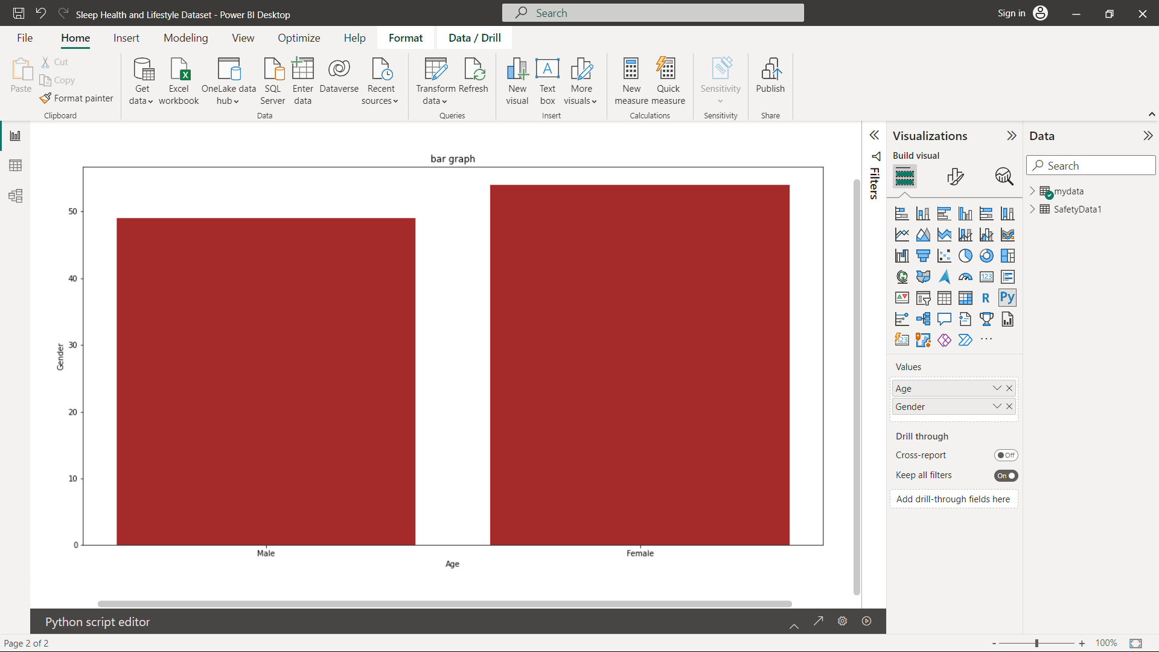
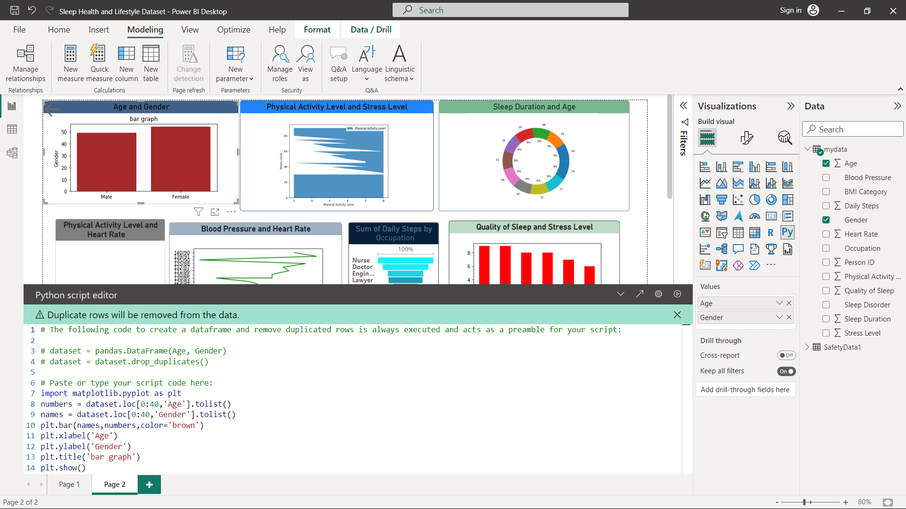
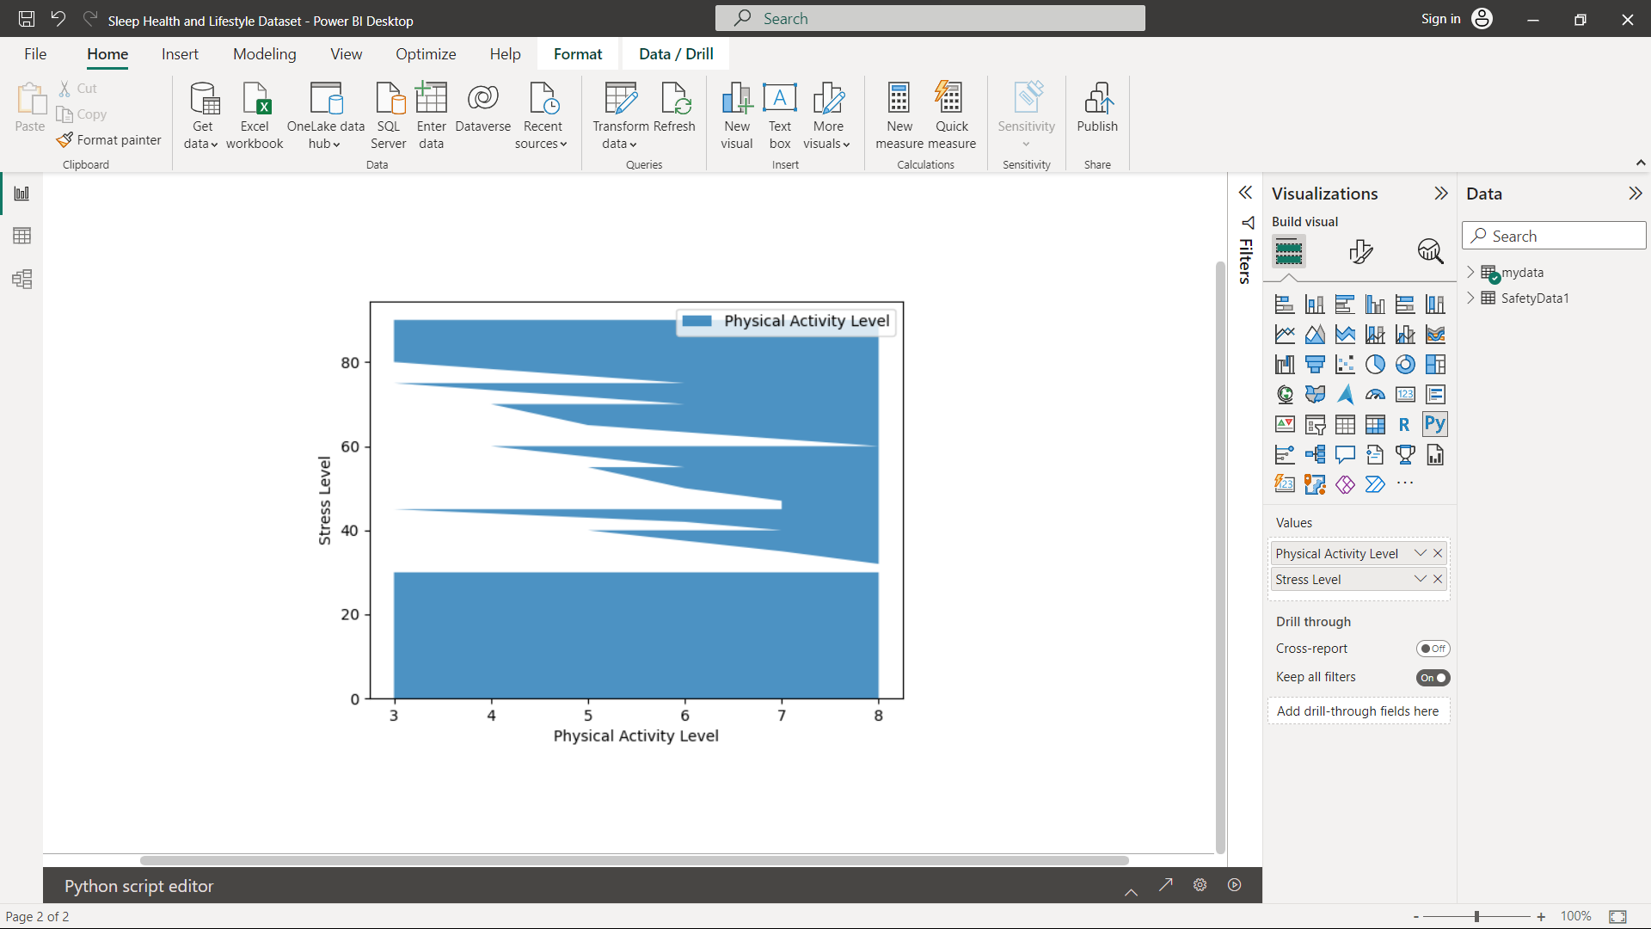

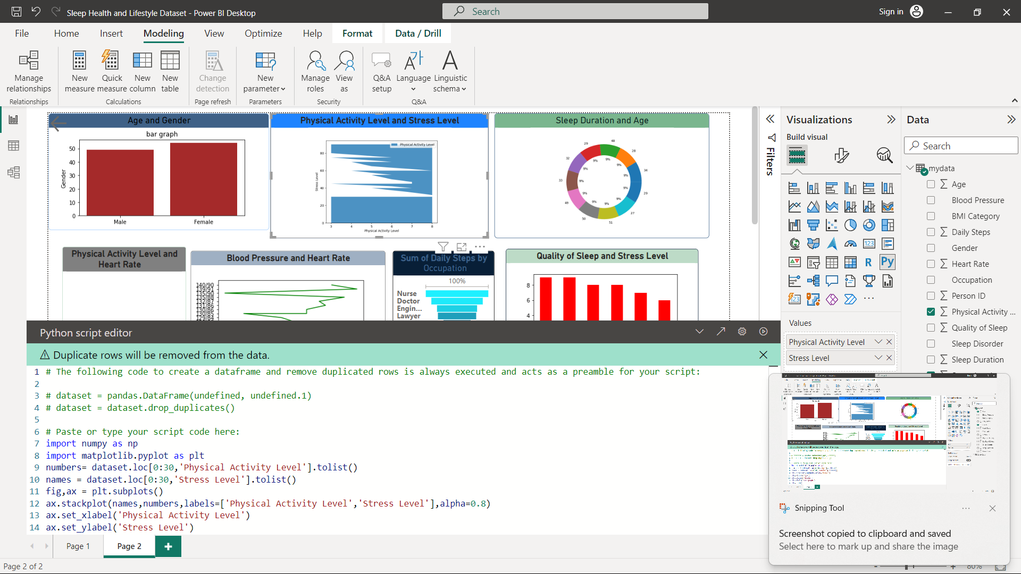

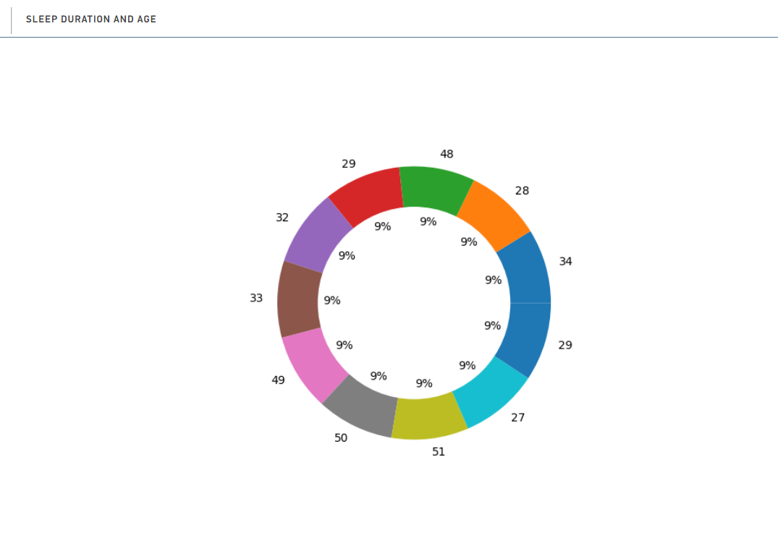
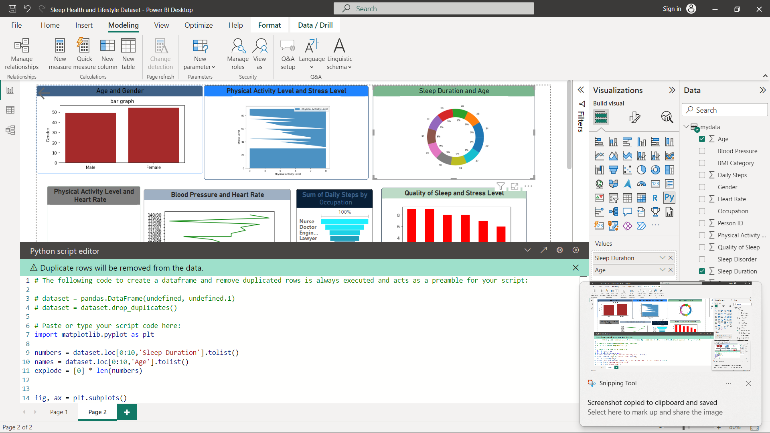
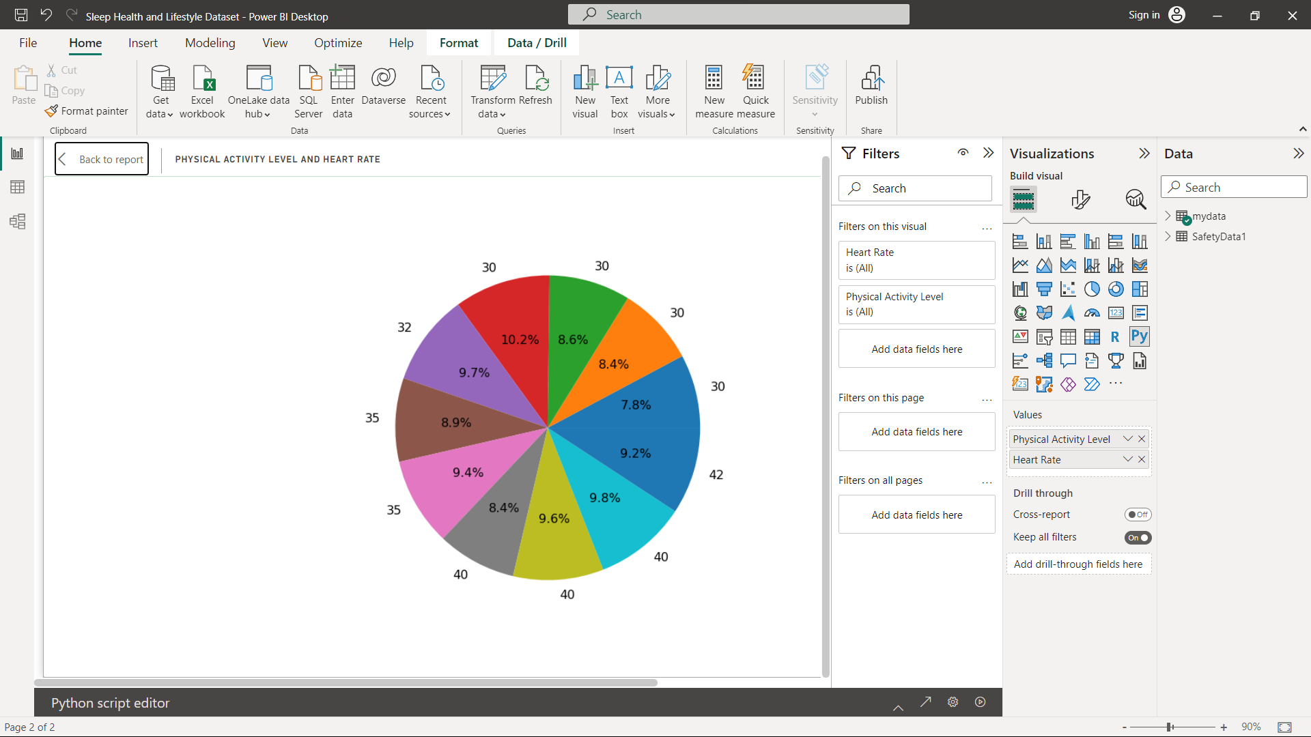

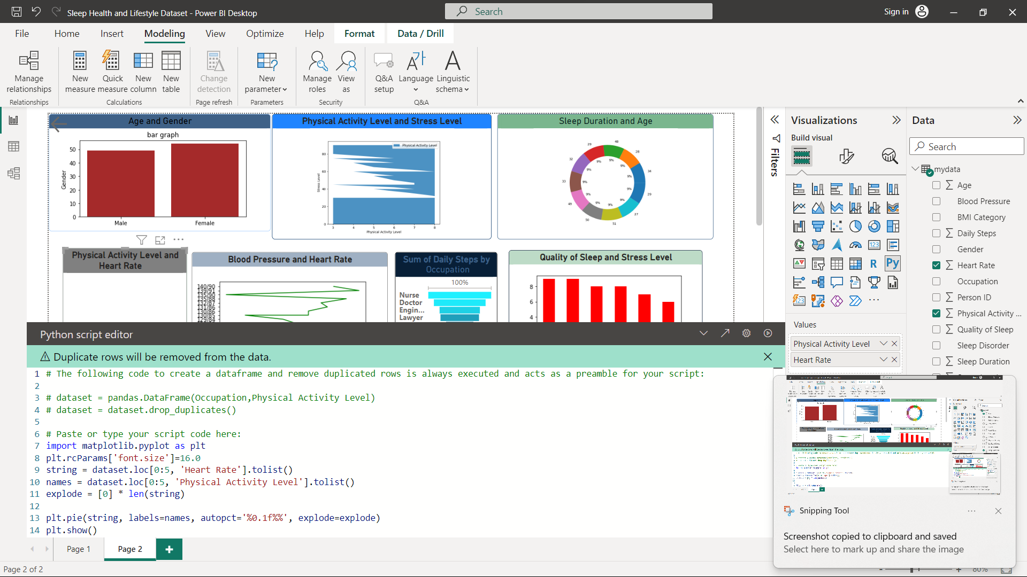

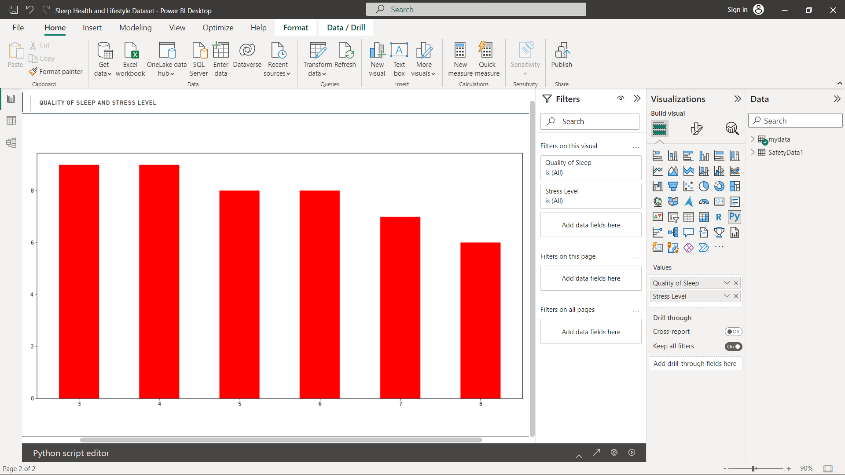

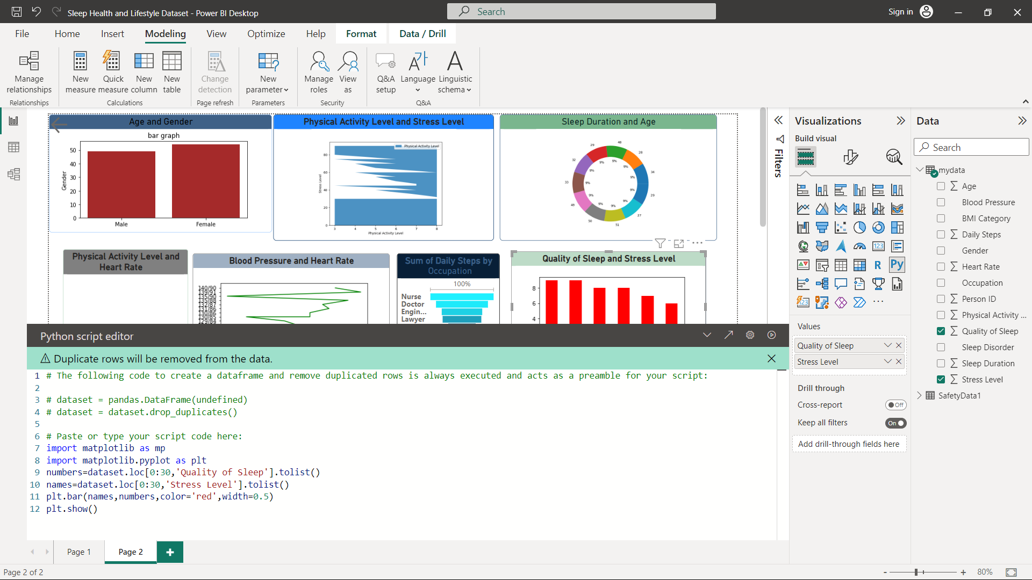

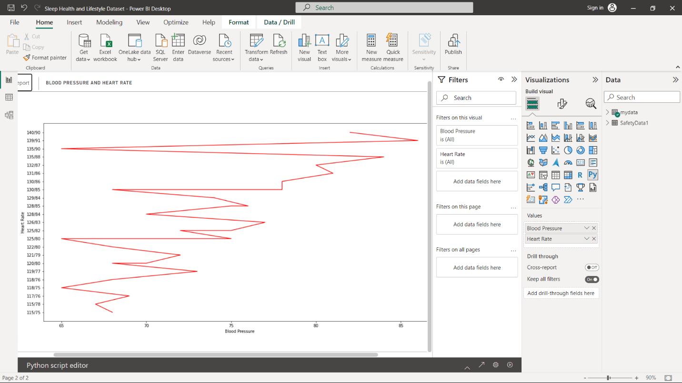

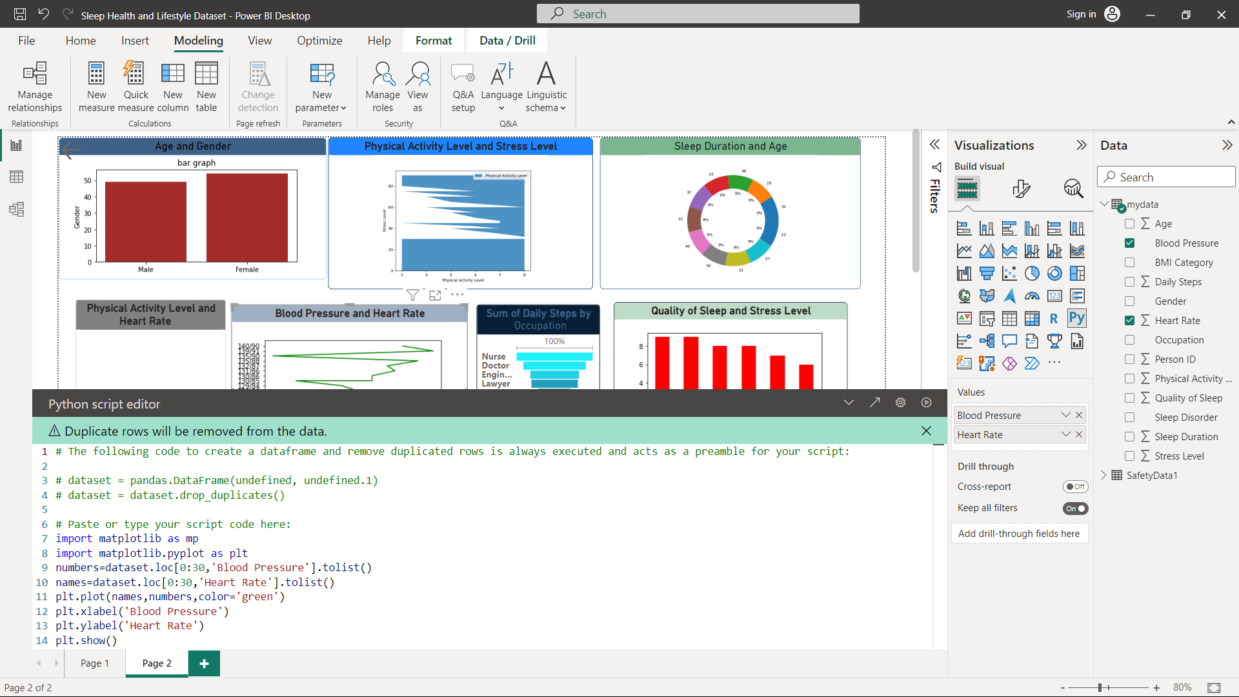

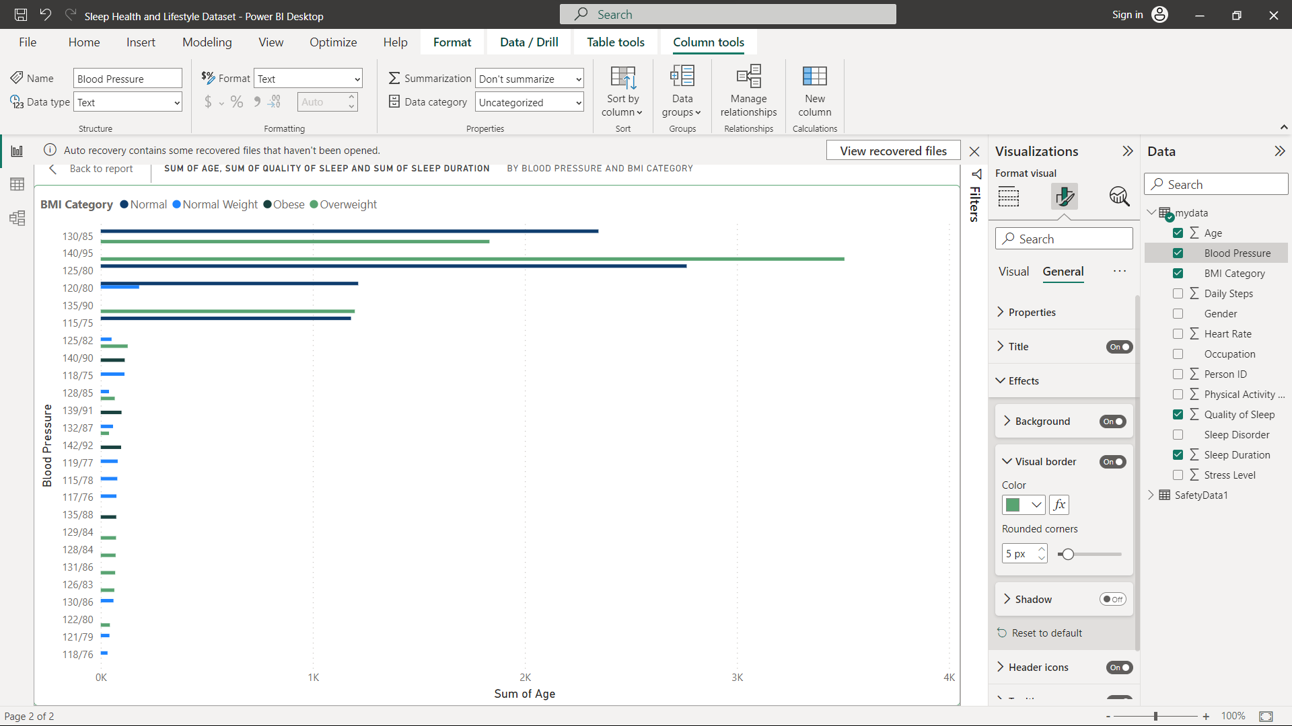
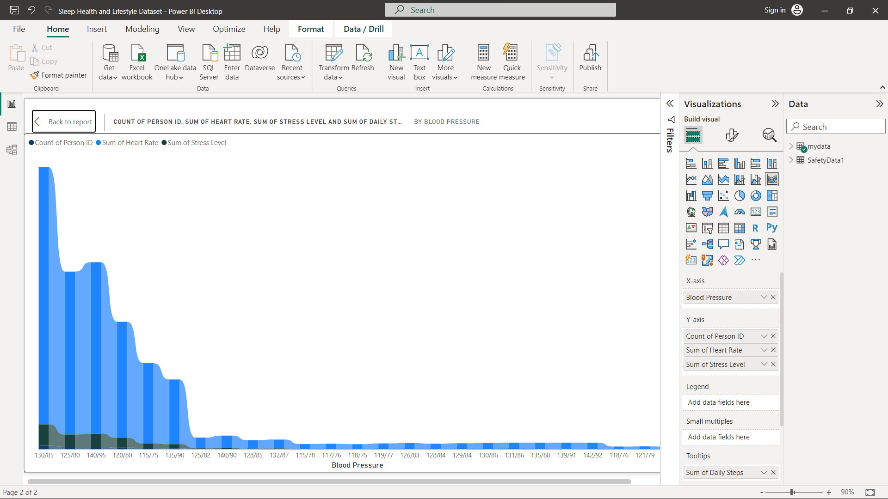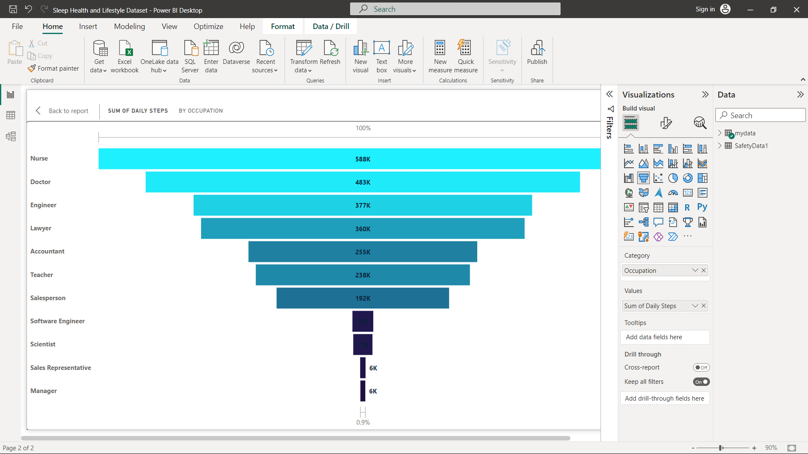
SLEEP HEALTH AND LIFESTYLE OF DASHBOARD :

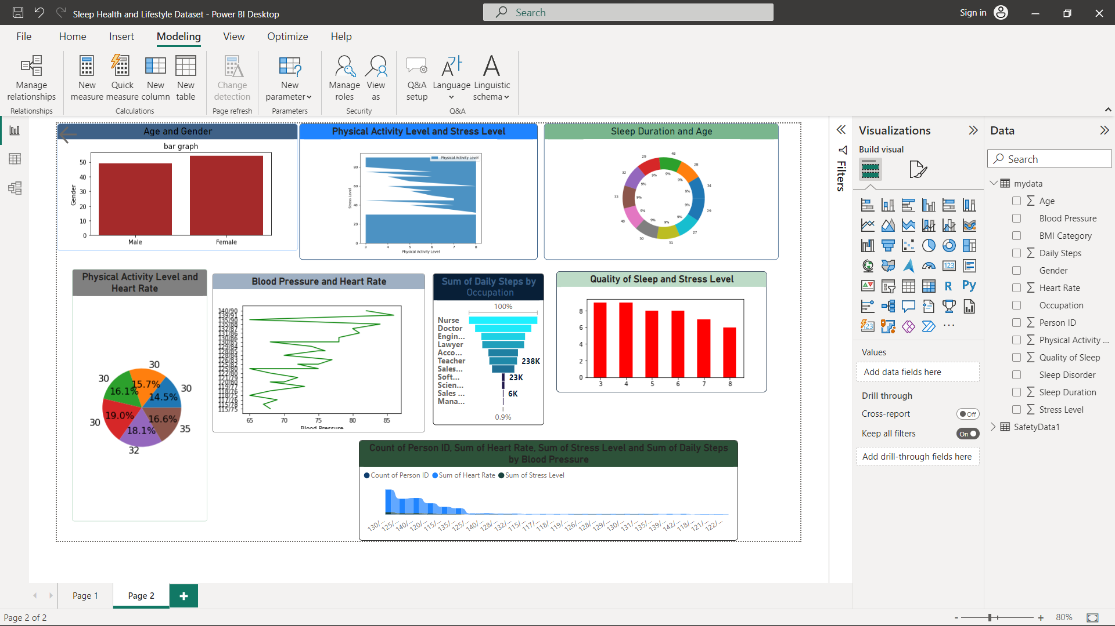

CONCLUSION :
In conclusion, the sleep health and lifestyle dataset presented in Power BI provides valuable insights into the relationship between sleep patterns and various lifestyle factors. Through this dataset, we have gained a deeper understanding of the impact of sleep on overall well-being and the importance of maintaining healthy sleep habits.

The analysis of the dataset has highlighted several key findings. Firstly, it has revealed that individuals who consistently adhere to recommended sleep durations experience better physical and mental health outcomes. Adequate sleep has been associated with improved cognitive function, increased productivity, and a reduced risk of chronic conditions such as obesity, diabetes, and cardiovascular diseases.

Furthermore, the dataset has shed light on the various lifestyle factors that influence sleep quality. Factors such as physical activity, stress levels, and screen time before bed have been shown to significantly impact the duration and quality of sleep. This information underscores the importance of adopting healthy lifestyle practices to promote better sleep and overall health.

The Power BI presentation of the sleep health and lifestyle dataset has provided an interactive and visually engaging platform for exploring the data. The use of charts, graphs, and interactive dashboards has allowed for easy identification of trends and patterns, enabling users to make data-driven decisions regarding their sleep habits and lifestyle choices.

By leveraging the insights from this dataset, individuals, healthcare professionals, and policymakers can develop targeted interventions and strategies to improve sleep health on both individual and societal levels. This dataset serves as a valuable resource for promoting public awareness, implementing effective sleep health programs, and designing policies that prioritize adequate sleep for optimal well-being.

In conclusion, the sleep health and lifestyle dataset presented in Power BI has deepened our understanding of the crucial role sleep plays in our lives and highlighted the importance of adopting healthy sleep habits. By leveraging the insights provided by this dataset, we can work towards improving sleep health and overall quality of life for individuals and communities.

FUTURE ENHANCEMENT :
Future enhancements for the sleep health and lifestyle dataset in Power BI can focus on expanding the scope and depth of the data analysis, as well as improving the user experience. Here are some potential areas for improvement:

1. Longitudinal Analysis: Incorporate data collection over an extended period to enable longitudinal analysis. Tracking sleep patterns and lifestyle factors over time can provide valuable insights into trends, seasonal variations, and the long-term effects of sleep habits on health outcomes.

2. Integration with Wearable Devices: Integrate the dataset with wearable devices that monitor sleep patterns and collect real-time data. This integration would allow for more accurate and comprehensive data collection, providing users with personalized insights and recommendations based on their individual sleep metrics.

3. Social and Demographic Analysis: Enhance the dataset by including social and demographic factors such as age, gender, socioeconomic status, and occupation. This additional information can help identify specific sleep patterns and lifestyle trends among different demographic groups, enabling targeted interventions and tailored recommendations.

4. Comparative Analysis: Enable comparative analysis by incorporating benchmark data from similar populations or national sleep surveys. Comparing sleep patterns and lifestyle factors across different regions or populations can provide valuable insights into cultural variations and identify areas for improvement.

5. Predictive Analytics: Utilize predictive analytics algorithms to forecast sleep patterns and assess the potential impact of lifestyle changes on future sleep health. This feature can empower individuals to make informed decisions about their daily routines and help healthcare professionals develop personalized sleep management plans.

6. Data Visualization Enhancements: Improve the visualization capabilities of the Power BI dashboard by introducing more interactive and dynamic charts, graphs, and visual elements. This enhancement will enable users to explore the data more effectively, uncover hidden patterns, and derive actionable insights.

7. Mobile-Friendly Interface: Optimize the Power BI dashboard for mobile devices to ensure a seamless user experience on smartphones and tablets. This enhancement will enable users to access and interact with the sleep health and lifestyle dataset on-the-go, empowering them to make informed decisions about their sleep habits.

8. Collaboration and Sharing Features: Introduce collaboration and sharing features within the Power BI platform, allowing users to share insights, reports, and recommendations with their healthcare providers, family members, or support networks. This functionality can facilitate collaborative efforts in improving sleep health and encourage accountability and support.

By implementing these future enhancements, the sleep health and lifestyle dataset in Power BI can become a more comprehensive and powerful tool for analyzing and improving sleep habits. These improvements will provide users with enhanced insights, facilitate personalized recommendations, and contribute to promoting better sleep health and overall well-being.
FOR BETTER INSIGHTS :
To provide better insights for the sleep health and lifestyle dataset in Power BI documentation, consider the following approaches:

1. Segment Analysis: Perform in-depth segmentation analysis based on various factors such as age, gender, occupation, and geographic location. This will help identify specific sleep patterns and lifestyle trends within different segments of the population, allowing for targeted interventions and tailored recommendations.

2. Correlation Analysis: Explore the correlations between sleep patterns and lifestyle factors to uncover relationships and dependencies. Analyze how variables such as physical activity, stress levels, alcohol consumption, and screen time before bed impact sleep quality and duration. Visualize these correlations using scatter plots, heat maps, or correlation matrices for better comprehension.

3. Sleep Trends over Time: Examine sleep trends over time to identify any significant changes or patterns. Utilize time-series analysis techniques to highlight seasonal variations, day-of-week effects, or long-term trends. This analysis can help individuals and healthcare professionals understand how sleep patterns may be influenced by factors such as work schedules, holidays, or lifestyle changes.

4. Sleep Quality Metrics: Introduce metrics for assessing sleep quality, such as sleep efficiency, awakenings, or sleep fragmentation. These metrics provide a more comprehensive understanding of sleep health beyond just sleep duration. Visualize these metrics using histograms or box plots to showcase the distribution and variations in sleep quality among different individuals or groups.

5. Sentiment Analysis: Incorporate sentiment analysis techniques to analyze subjective sleep experiences. Leverage natural language processing (NLP) algorithms to analyze textual data from sleep diaries, surveys, or social media. This analysis can uncover insights into individuals' emotional states related to their sleep, highlighting areas of improvement or specific challenges.

6. Comparative Analysis: Compare sleep health and lifestyle factors across different population groups, regions, or demographic categories. Utilize benchmark data from national sleep surveys or similar datasets to identify areas of improvement or potential disparities. Visualize these comparisons using bar charts, stacked charts, or geographic maps to highlight differences and similarities.

7. Machine Learning Predictions: Apply machine learning algorithms to predict sleep outcomes based on lifestyle factors. Develop predictive models that can estimate sleep quality, sleep disorders, or the risk of certain health conditions associated with poor sleep. This can empower individuals to take proactive measures to improve their sleep habits and overall well-being.

8. Recommendations and Actionable Insights: Summarize key findings and provide actionable insights and recommendations based on the data analysis. Incorporate best practices and evidence-based guidelines for improving sleep health and lifestyle habits. Communicate these recommendations clearly and concisely, using visuals, infographics, or data-driven narratives to facilitate understanding and engagement.

By implementing these strategies for better insights, the Power BI documentation for the sleep health and lifestyle dataset can provide users with comprehensive and actionable information. These insights can empower individuals to make informed decisions about their sleep habits, encourage behavior change, and support healthcare professionals in developing personalized sleep management plans.

